MAKER ID- NO APPLICATION AVAILABLE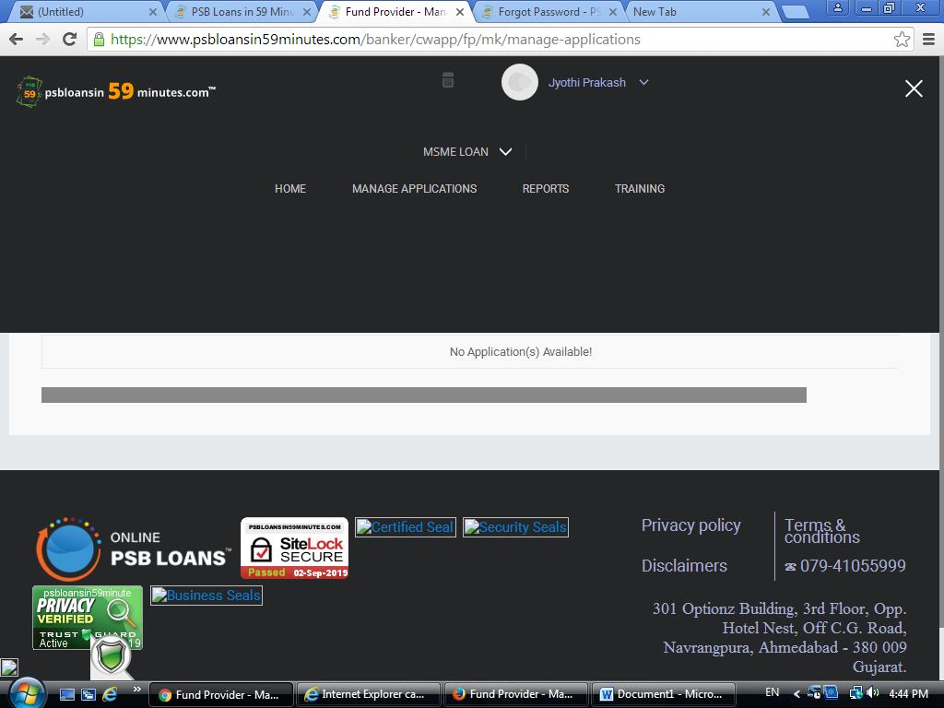

NO PROPSAL PENDING IN CHECKER CODE

